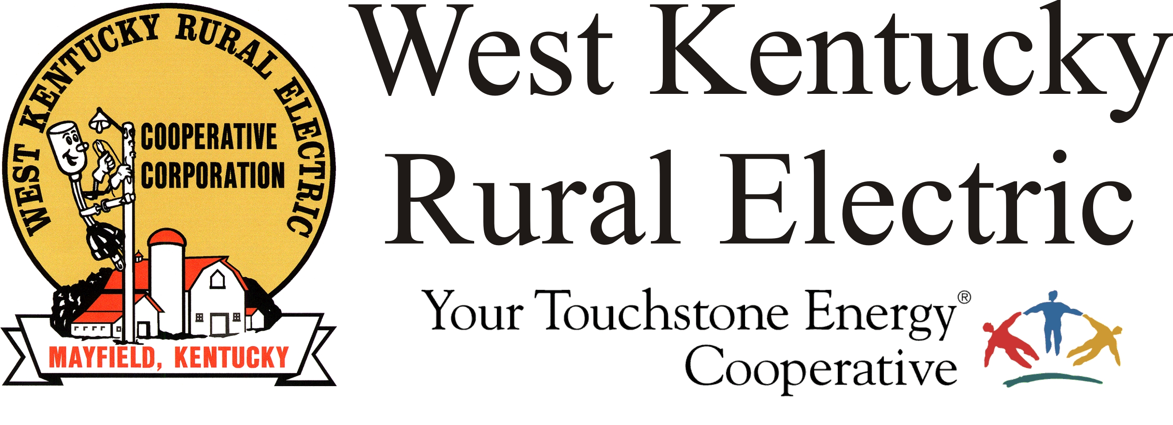

Storm Causes Widespread Power Outages Across
West Kentucky RECC Service Area

(Mayfield, Ky.) Dec. 11, 2021 (1:45 a.m.) – A tornado passed through the West Kentucky Rural Electric Cooperative service area overnight, leaving behind widespread damage to the power distribution system that serves 31,000 members in four Western Kentucky Counties.

“Right now, we have power to just three of the co-op’s 13 electrical substations due to damage to TVA’s transmission system,” said WKRECC President & CEO David Smart. “We also sustained widespread damage to the lines and poles that deliver power to the communities, homes and businesses we serve.”

“This is going to be a lengthy repair process,” Smart said. “We are continuing to assess damage and we’ll have a better idea later this morning of just what we are dealing with.” He said members with electricity-dependent medical devices should make plans to secure a generator or temporarily relocate. “Please take any necessary steps to make sure your family is safe,” Smart added.

WKRECC will issue an updated outage status report Saturday around 9:30 a.m.

The co-op’s headquarters in Mayfield escaped damage, though the warehouse just outside the city lost sections of its roof. The damage did not affect the trucks or support equipment.

Due to problems with internet and phone service, WKRECC does not have accurate outage numbers at this time. Phone service has been restored and members can call in outage reports. The outage map is currently offline.

“We will be doing everything possible to restore service to our members, including brining in mutual aid resources,” Smart said. “We appreciate your patience.”

Helpful Facts

- If you see a downed power line, STAY AWAY and call WKRECC at 1-877-495-7322 to report the problem.
- If you or someone in your household has health issues that require electrically-powered devices, consider going to stay with family or friends who have electricity or move to a hotel if possible.
- Turn off computers, televisions and other digital equipment and appliances.
- Avoid opening the freezer door. A full, freestanding freezer will keep food at freezing temperatures about two days; a half-full freezer about one day. For more information about food safety go to www.foodsafety.gov.

- Protect yourself from carbon monoxide poisoning. DO NOT operate generators indoors; the motor emits deadly carbon monoxide gas. DO NOT use charcoal to cook indoors. It, too, can cause a buildup of carbon monoxide gas.

###

