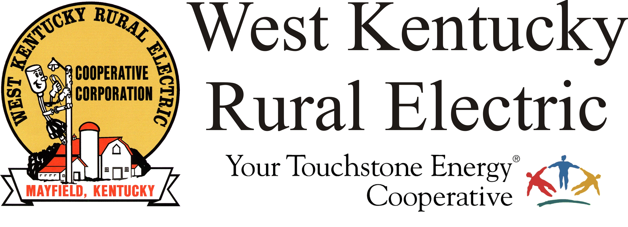

West Kentucky RECC Monday Evening
Storm Damage Update

(Mayfield, Ky.) Dec. 13, 2021 (6:10 p.m.) – Good news! TVA has restored service to all WKRECC substations, reducing the total number of members without service to 3,860. This is a great step forward, down from the initial 28,000 on Saturday morning. We appreciate TVA’s commitment to WKRECC and our members.
Most of the remaining outages are in Graves and Marshall counties and occurred as the deadly tornado tore through homes and businesses on its path across our service area. It left behind a wasteland of downed lines and poles and dangerous debris. Seasoned lineworkers say the damage here is worse than what they have seen with major hurricanes and ice storms.
Repairs will be made over the next several days with a continuing emphasis on safety for our members and staff. We will be working around the clock to make repairs. To report an outage, call 1-877-495-7322 and use option 1 to leave a recorded message.
Right now, we have about 100 lineworkers supplementing our staff, for a total of 125 experienced professionals. We are also deploying professional tree services and debris removal teams.
Technology outages have challenged us from the start of this recovery. Damaged regional communication systems have limited our access to phones, the internet, and the internal electronics that help us track and report outage status. This afternoon some of those systems are coming back online, which will help us provide more accurate information to our members going forward.
Reminders:
- Business offices in Murray and Benton will open on Tuesday at 1 p.m. The Mayfield office will reopen later. During regular business hours, customer service representatives are available to answer questions about your account. Call 1-877-495-7322. Be advised that wait times have been lengthy.
- Disconnects for non-payment are temporarily suspended. We will announce when disconnects resume.
___________________________________________________________

Georgann Lookofsky, 270-804-1701 or glookofsky@wkrecc.com

