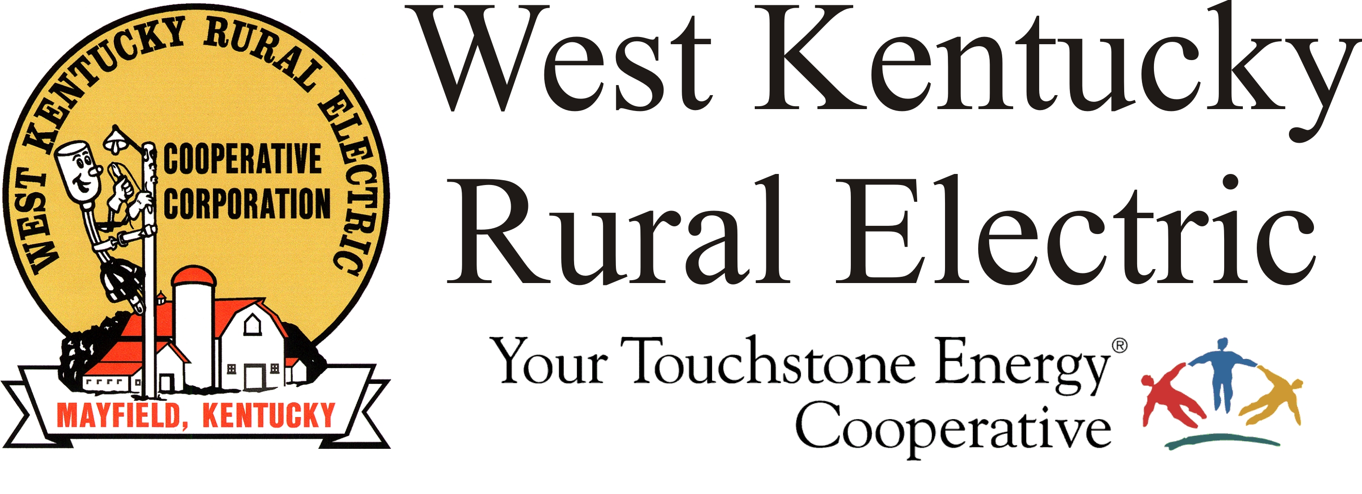

FOR IMMEDIATE RELEASE

West Kentucky RECC Completes Storm Damage Repairs

(Mayfield, Ky.) Dec. 20, 2021 (10:00 a.m.) – Late Sunday night, West Kentucky Rural Electric Cooperative and its visiting crews completed repairs to the distribution system resulting from the EF4 tornado that slashed across the service area on Dec. 10. The lights are back on for all WKRECC members whose homes are capable of being reconnected.
“This has truly been an amazing effort by our crews and the visiting crews and contractors that partnered with us to get the lights back on for our members,” said WKRECC President & CEO David Smart. “We are thankful to be part of the cooperative family and to have these resources available to help when we need it most.” Initial reports show WKRECC has replaced about 400 broken poles and more than 20 miles of line over the past week.
“Today our thoughts and prayers are with our members who have lost loved ones or lost their homes and treasured possessions. We are encouraged by and thankful to the many groups and organizations who are stepping in to help,” Smart added.
WKRECC will continue cleanup work today across the area. If your home is intact and your neighbors have power, but you do not, please call WKRECC at 1-877-495-7322 to report your outage.
We will also be working to reconnect homes as repairs and inspections are completed.
All business offices have reopened. Our website, and online payment tools are also operational.
“WKRECC is very thankful for everyone who supported our efforts to feed and house our crews throughout this repair effort and for everyone who has reached out with a message of hope and encouragement,” said Smart. “We are truly stronger together.”
###

Georgann Lookofsky, 270-804-1701 or glookofsky@wkrecc.com

