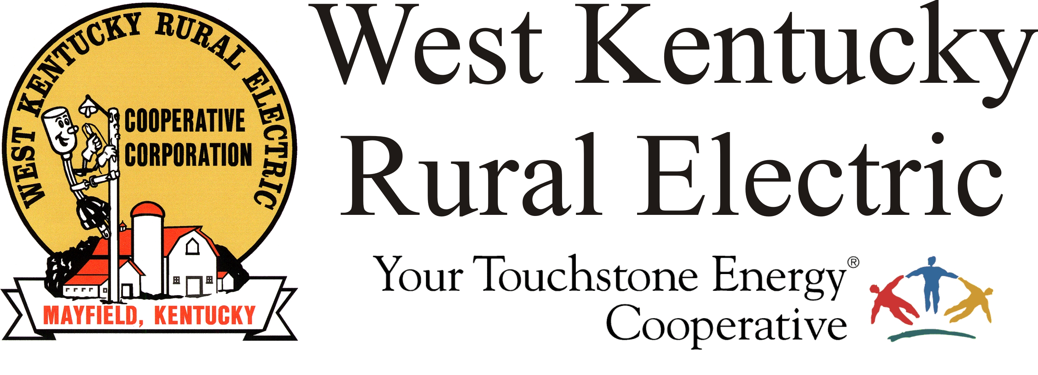

West Kentucky RECC Wednesday Morning
Storm Damage Update

(Mayfield, Ky.) Dec. 15, 2021 (1:20 a.m.) – This morning we have 830 members still without electricity across the WKRECC service area. As expected, the pace of restoration has slowed, as each outage location presents its own set of problems. The wet, windy conditions forecast for today won’t help either, but we won’t quit. Our crews will continue to work as long as it is safe to be outdoors.
Today we want to salute our industrial members, Saluna, Vanderbilt Chemical, Pella Windows and Doors, and many others, who voluntarily gave up or reduced their power supply so that more homes could be energized. We are grateful for their support and proud to serve such a caring business community.
Energy conservation is no longer needed and the system is stable. Your support helped us put more people on at a critical time--thank you!
The WKRECC website is back in service at its usual address, www.wkrecc.com. Online bill-pay and other automated services are also back in service. We are not currently charging credit card fees.
The Murray and Benton business offices are open. The Mayfield office is closed, however, members are encouraged to use the night deposit. We are processing payments daily.
To report an outage, call 1-877-495-7322 and use option 1 to leave a recorded message.
Reminders:
- Regarding debris, we understand that FEMA has asked property owners to pile debris at the curb. However, please don’t pile debris on top of downed power lines. Move the pile back slightly to give us space to work. Thanks for your consideration in this matter.
- Be alert for scams. If you receive a call demanding payment and threatening to disconnect your service, don’t be a victim!
- Disconnects for non-payment are temporarily suspended. We will announce when disconnects resume.
___________________________________________________________

Georgann Lookofsky, 270-804-1701 or glookofsky@wkrecc.com

