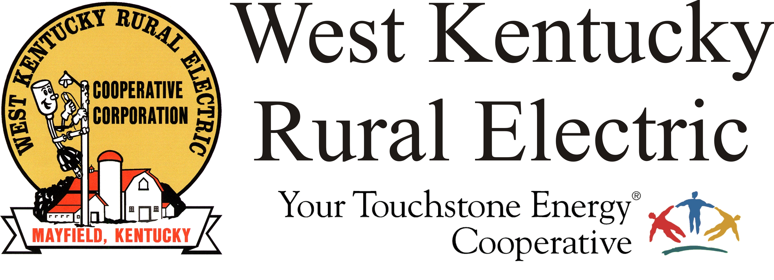

West Kentucky RECC Tuesday Morning
Storm Damage Update

(Mayfield, Ky.) Dec. 14, 2021 (11:15 a.m.) – Outage restoration continues to move forward. We have turned the lights back on for about 26,000 members in the three days since the tornado struck.
The 2,000 members without power are mostly in areas of Graves and Marshall counties with heavy damage. We expect the pace of restoration to slow, as each outage location poses its own unique challenges to our crews. Please know that we are working as quickly as possible given the conditions, and that we won’t stop until everyone who can receive service is back on. To report an outage, call 1-877-495-7322 and use option 1 to leave a recorded message.
Our website, outage map and email service remain offline. U.S. Mail service is restored.
Reminders:
- We expect the Mayfield office will remain is closed for the remainder of the week. Members are encouraged to use the nigh deposit box. Payments are being processed daily. We are also processing mail payments, send to P.O. Box 589, Mayfield KY, 42066.
- The Murray and Benton offices will reopen later today. Night drop boxes are available at these locations.
- Customer service representatives are available to answer questions about your account during regular business hours. Call 1-877-495-7322 for assistance.
- Disconnects for non-payment are temporarily suspended. We will announce when disconnects resume.
___________________________________________________________

Georgann Lookofsky, 270-804-1701 or glookofsky@wkrecc.com

